Engineering Advances 2026
Type Paper Title Here: Carefully Write Your Abstract as Per Instructions in This Template
Full Author Name, Graduate Scholar, Name of the Department, Institute Name (as applicable), City, Country
Rozek Jhon Pome, Post Graduate Scholar, Name of the Department, University Name (as applicable), City, Country
Suraj M. Verma, Research Scholar, Name of the Department, Research Centre Name, City, Country
Le Miu, Associate Professor, Name of the Department, Research Centre Name, City, Country

(All authors emails in sequence and corresponding author with*: firstauthor@email.com*, secondauthor@email.com, thirdauthor@email.com, fourthauthor@email.com)

ABSTRACT
Please read this paragraph carefully before preparing the abstract. It will help you to prepare the abstract as per guidelines of Engineering Advances 2026: Second International Conference. The abstract should be prepared in a single paragraph only. Abstract can describe the 1) Background of research or review, 2) Objectives of the paper, 3) Methods used and the novelty of the work, 4) Results or outcome and, 5) Conclusion of the work in brief (may be 2-3 sentences about each). All main body sections should be summarized appropriately in the abstract. The abstract word limit is strictly from 200 to 300 words. Please prepare an abstract on A4 size paper with normal margin as per this template. Use three to five keywords in alphabetical order separated with semicolons which will help readers to search and retrieve your paper through the internet. Keywords should ideally be phrases of 2-4 words; single word keywords are acceptable, but they may lead to many false matches. Abstracts not following these guidelines will not be processed further. It is considered that the submitting author has read and followed all necessary guidelines before the abstract submission. Also, it is assumed that all authors are aware about the necessary information about the author's ethics, plagiarism, registration, presentation and publication before the submission of the abstract. (Times New Roman, 12, line spacing 1.15).

Keywords: Abstract template; content guidelines; template information. (Times New Roman, 10 Italic)
- INTRODUCTION
Please read this template carefully before writing a research paper. This will save your time and you can prepare your paper as per the publication requirement [1]. It is appreciable to follow the template guidelines for timely processing of the article. Use the “Times New Roman” font of size 12 thorough out the paper except the Title and Paper ID. Line spacing for full paper should be 1.15 strictly.

- STRUCTURE OF THE PAPER
Your paper should consist of,
- Title,
- Author’s names, Affiliations, Emails,
- Abstract, Keywords,
- Body text (Introduction, Methods, Results, Discussion and Conclusion) and
- References

  - Abstract and Keywords
Abstract can describe the background of research or review, objective of paper, methods used, and the novelty of the work, outcome and conclusion of the work in brief. All these sections should be presented appropriately. For Engineering Advances 2026 has restricted the abstract word limit is strictly set from 200 to 300 words. Add three to five important keywords which will be used for search and indexing.
  - Page Limit
Numbers of pages are limited to 8. There will be extra charges of INR 500 / USD 10 for each additional page. Please do not add page numbers in the footer.
  - Body Text
Writing an appropriately structured research paper is essential for effectively communicating research findings, establishing credibility, and contributing to the advancement of knowledge in the field.
Prepare your research paper body text in simple FIVE SECTIONS. All section names must be numbered and typed as bold uppercase words.
- Introduction
- Methods
- Results
- Discussion
- Conclusion

- Research Paper Structure (Table title must be before table)
Sr. | Section | Description
 | Title | The title should be concise, descriptive, and accurately reflect the content of the paper.
 | Authors and Affiliation | Write full s names and correct affiliations of all authors. Also write all emails in sequence.
 | Abstract | The abstract provides a brief summary of the entire paper, including the research question, methods, results, and conclusions. It helps readers quickly understand the purpose and significance of the study. (200 - 300 words)
1. | Introduction | Sets the platform for the research by providing background information on the topic, stating the research question or hypothesis, and outlining the objectives of the study.  It also includes a brief review of relevant literature and explains the significance of the research.
2. | Methods | Describes how the research was conducted, including the study design, participants or sample, materials and instruments used, and procedures followed. It should provide sufficient detail to allow other researchers to replicate the study.
3. | Results | Presents the findings of the study in a clear and organized manner. It may include text, tables, figures, and graphs to summarize the data collected. Results should be presented objectively, without interpretation.
4. | Discussion | Interprets the results in the context of the research question, compares them with previous studies, and discusses their implications.  It may also address any limitations of the study and suggests directions for future research. The discussion may end with a summary of the key findings and their significance.
5. | Conclusion | The conclusion summarizes the main findings of the study and reiterates the significance of the research.  It may also emphasize the broader implications of the findings and suggest potential applications or areas for further investigation.
 | References | The references section lists all sources cited in the paper, as per specified citation style

Review paper body text may consist of Introduction, sections and subsections that focus on different aspects of the topic and conclusion. The body of the review paper should be organized logically and coherently, with smooth transitions between sections.
- Sub subsections
Sub sections and sub subsections can be added appropriately and typed as bold title case words. They can be numbered as 2.1 and 2.2.1 as illustrated here.
- Instructions
Please remove the instructions given in this paper, before submission.
  - References
- Check that all possible relevant and recent references are used and cited in the paper.
- There is no limit on the number of references.
- All references are numbered as [1], [2], [3, 4], [5-9] etc. in the main body in sequence.
- Irrelevant self-citations should not be used.
- Reference section should not be numbered.
Authors can use following details / sequence when adding references in References section. Also, check the reference section for more understanding.
  - Plagiarism
No part of the text should be copied from others or previous own articles. Any type of plagiarism will not be tolerated. If figures are used from other sources are cited properly and not violating copyright laws.
  - Proofreading
After drafting your paper, carefully proofread it for grammar, punctuation, and spelling errors.
- OTHER GUIDELINES
Please read and implement following simple instructions.
- Basic Guidelines
- Paper with less than 6 pages or 2000 words will not be processed.
- Use 1.15 spacing, Times New Roman font of size 12. As mentioned above, all sections should be numbered.
- English language should be concise and clear. Avoid very long unnecessary sentences. If required, take help of online tools or English experts before paper submission. Use appropriate articles and prepositions.
- Before submission, check your paper for spellings and grammar
- Add Nomenclature and abbreviations you used before the reference section.
- Guidelines for Figures, Tables and Equations
- Figures should be neat and clear and not less than 300 dpi, centrally placed. Figure numbers should start from 1 and increase orderly irrespective of the section number. For example, Fig. 1, Fig. 2, Fig. 3, etc. Place Figure number and figure title below the figure.
- Table numbers should start from 1 and increase orderly irrespective of the section number. For example, Table. 1, Table. 2, Table. 3, etc. Place Table number and Table title above the table.
- Check all Figures, Tables and Equations are referred or cited in the text.
- Refer screenshots in Fig. 1. to Fig 3. for inserting equations.
- Equations should be appropriately numbered as (1), (2), etc.

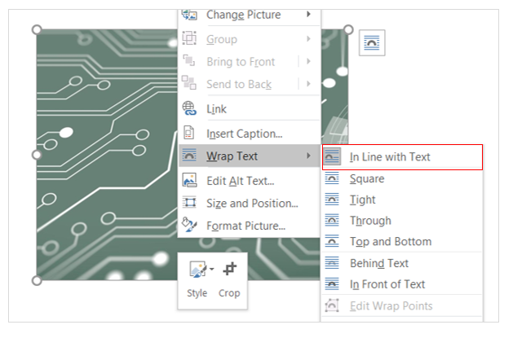
- Main menu screenshot for adjusting figure – In line with text (figure title must be after figure)
- Object screen screenshot of adding equations
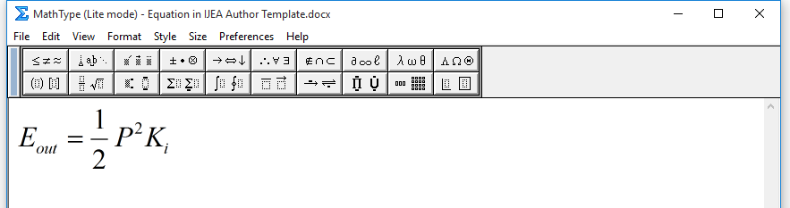
- Mathtype pop up window
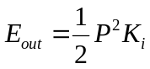 (1)
- CONCLUSION
Conclusions should not a repetition of sentences from the Abstract and body text. Do not add insignificant statements of your results in this section. It should summarize the most important clear scientific results of the research work, their novelty, benefits, and limitations.

ACKNOWLEDGEMENT
Acknowledgments of grants, funds, etc. should be placed here. The names of funding organizations should be written in full. Please do not acknowledge your guide or supervisor as he/she is also one author.
References
The number and length of references is not limited. Authors are encouraged to include the latest relevant research work from the reputed journals. Reference citations in the text should be identified by numbers in square brackets [5-8]. Authors can see the references given at the end for more details.
Please use IEEE reference style with full journal titles, book titles and conference titles.

- R. Fardel, M. M. Chiampi and L. L. Zilberti, “Induction of electric field in human bodies moving near MRI: An eﬃcient BEM computational procedure,” IEEE Engineering Journal, pp. 2787–2793, Oct. 2011, Art. no. 15426. https://doi.org/ 10.1109/TBME.2011.158315 .
- M. Ito, “Can the application of amorphous oxide TFT be an electrophoretic display?,” Journal of Solids, vol. 354, no. 19, pp. 2777–2782, Feb. 2008, Art. no. 15426. https://doi.org/ 10.1109/JS.2006.345641
- G. Veruggio, “The EURON roboethics roadmap,” in Proceedings of Humanoids ’06: 6th IEEE-RAS International Conference Humanoid Robots, July 2006, pp. 612–617. https://doi.org/ 10.1109/2006.321337.
- A. Amador-Perez and R. A. Rodriguez-Solis, “Analysis of a CPW-fed annular slot ring antenna using DOE,” in International Conference Humanoid Robots, vol. 3, 2nd ed., Jul. 2006, pp. 4301–4304. https://doi.org/ 10.15444/321337
- R. L. Myer, “Parametric oscillators and nonlinear materials,” in Nonlinear Optics, vol. 4, P. G. Harper and B. S. Wherret, Eds., San Francisco, CA, USA: Academic, 1977, pp. 47–160. https://doi.org/ 10.15444/321337
- T. Ogura, “Electronic government and surveillance-oriented society,” in Theorizing Surveillance: The Panopticon and Beyond. London, U.K.: Willan, 2006, ch. 13, pp. 270–295. https://doi.org/ 10.15444/321337
- L. Stein, “Random patterns,” in Computers and You, J. S. Brake, Ed., New York, NY, USA: Wiley, 1994, pp. 55–70. https://doi.org/ 10.15444/321337
- C. Bennett, “What happens when you book an airline ticket? The collection and processing of passenger data post-9/11,” in Global Surveillance and Policing: Borders, Security, Identity, E. Zureik and M. Salter, Eds., Cullompton, U.K.: Willan, 2005, pp. 113–138. https://doi.org/ 10.15444/321337
- W. R. Leonard and M. H. Crawford, Eds. Human Biology of Pastoral Populations. New York, NY, USA: Cambridge University Press, 2002. https://doi.org/ 10.15444/1455587

Guidelines for Referencing Style

Journal / Periodicals with Article ID
Basic Format:
J. K. Author, “Name of paper,” Journal / Periodicals Title, vol. x, no. x, month, year, Art. no. xxx.
Examples:
- R. Fardel, M. M. Chiampi and L. L. Zilberti, “Induction of electric field in human bodies moving near MRI: An eﬃcient BEM computational procedure,” IEEE Engineering Journal, pp. 2787–2793, Oct. 2011, Art. no. 15426. https://doi.org/ 10.1109/TBME.2011.2158315.
- M. Ito, “Can the application of amorphous oxide TFT be an electrophoretic display?,” Journal of Solids, vol. 354, no. 19, pp. 2777–2782, Feb. 2008, Art. no. 15426.

Conference Proceedings
Basic Format:
J. K. Author, “Title of paper,” in Name of Conference, (location of conference is optional), year, pp. xxx–xxx, https://doi.org/ xxx (if available)
Examples:
- G. Veruggio, “The EURON roboethics roadmap,” in Proceedings of Humanoids ’06: 6th IEEE-RAS International Conference Humanoid Robots, July 2006, pp. 612–617, https://doi.org/ 10.1109/ICHR.2006.321337.

Conference Proceedings with Series Title, Volume Title, and Edition
Basic Format:
J. K. Author, “Title of paper,” in Name of Conference in Volume Title, in Series Title, ed., year, pp.
xxx-xxx.
Example:
- A. Amador-Perez and R. A. Rodriguez-Solis, “Analysis of a CPW-fed annular slot ring antenna using DOE,” in International Conference Humanoid Robots, vol. 3, 2nd ed., Jul. 2006, pp. 4301–4304.

Book
Basic Format:
J. K. Author, “Title of chapter in the book,” in Title of Published Book, xth ed. City of Publisher, (only U.S. State), Country: Publisher, year, ch. x, sec. x, pp. xxx–xxx.
Example
- R. L. Myer, “Parametric oscillators and nonlinear materials,” in Nonlinear Optics, vol. 4, P. G. Harper and B. S. Wherret, Eds., San Francisco, CA, USA: Academic, 1977, pp. 47–160.

Book With Chapter Title
Basic Format:
J. K. Author, “Title of chapter in the book,” in Title of Published Book, X. Editor, Ed., City of Publisher, State (only U.S.), Country: Publisher, year, ch. x, sec. x, pp. xxx–xxx.
Examples:
- T. Ogura, “Electronic government and surveillance-oriented society,” in Theorizing Surveillance: The Panopticon and Beyond. London, U.K.: Willan, 2006, ch. 13, pp. 270–295.

Book With Editor(s)
Basic Format:
J. K. Author, “Title of chapter in the book,” in Title of Published Book, X. Editor, Ed., City of Publisher, State (only U.S.), Country: Publisher, year, pp. xxx–xxx.
X. Editor, Ed. Title of Published Book. City of Publisher, State (only U.S.), Country: Publisher, year.
Examples:
- L. Stein, “Random patterns,” in Computers and You, J. S. Brake, Ed., New York, NY, USA: Wiley, 1994, pp. 55–70.
- C. Bennett, “What happens when you book an airline ticket? The collection and processing of passenger data post-9/11,” in Global Surveillance and Policing: Borders, Security, Identity, E. Zureik and M. Salter, Eds., Cullompton, U.K.: Willan, 2005, pp. 113–138.
- W. R. Leonard and M. H. Crawford, Eds. Human Biology of Pastoral Populations. New York, NY, USA: Cambridge Univ. Press, 2002.

